
SECURING MONITORING HOME LAB
CYBERSECURITY IT REPORT WEEK 5.

2ND October, 2026
GROUP 2; CALEB, LAURA AND JADA
PROJECT REPORT.

- OBJECTIVES
- Build a multi-machine security lab inside VirtualBox.
- Set up a central SIEM SERVER (Wazuh) to collect and manage security logs.
- Prepare a deliberately vulnerable machine (Metasploitable 2) to act as the monitored endpoint.
- Deliver the Wazuh agent to the endpoint using a local web server, without needing internet access on the target.
- Register the endpoint with the Wazuh Manager and generate its authentication key.
- LAB ENVIRONMENT OVERVIEW.
The lab is made up of three virtual machines. Each has one clear job, which keeps the design simple and easy to explain.
Machine | Operating System | Role in the Lab
Staging host | Kali Linux (VirtualBox VM) | Downloads the agent installer and serves it to other machines on the lab network.
Target endpoint | Metasploitable 2 (VirtualBox VM) | The monitored machine. Represents a vulnerable server in a real company network.
Security server | Wazuh Manager 4.14.8 (official OVA) | The central SIEM hub that collects and manages security logs.
  - KEY TERMS IN PLAIN LANGUAGE.
- SIEM: a central hub that gathers security information from many machines so it can be watched in one place.
- Wazuh: an open-source security platform. In this lab it acts as “the security guard sitting inside the home lab.”
- Agent: a small program installed on a machine that reports its activity and logs back to the Wazuh Manager.
- Metasploitable 2: a purposely vulnerable machine used for safe security practice.
- IMPLEMENTATION.
3.1 HOST SETUP (KALI LINUX).
Kali Linux runs as a virtual machine in VirtualBox and serves as the primary staging host. Kali is a distribution built for penetration testing, security auditing and network management.
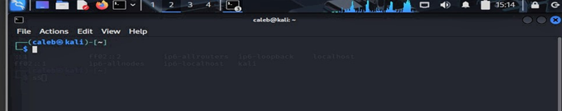
Figure 1: Kali Linux terminal on the staging host
3.2 TARGET ENDPOINT (METASPLOITABLE 2).
Metasploitable 2 runs in VirtualBox as an intentional target. It is the machine on which security monitoring is deployed, so that its activity can be detected and its system logs collected.
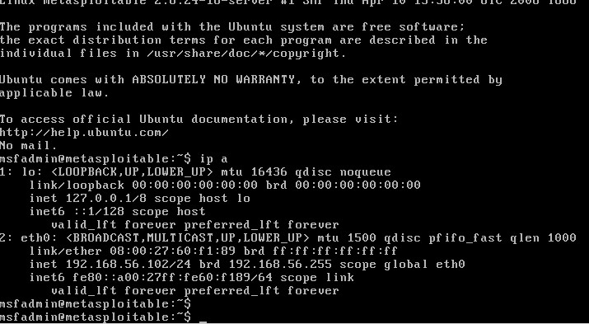
Figure 2: Metasploitable 2 console showing its network configuration (ip a)
3.3 CENTRAL SECURITY SERVER (WAZUH).
The Wazuh Manager was deployed from the official OVA image, which is a ready-made virtual appliance.
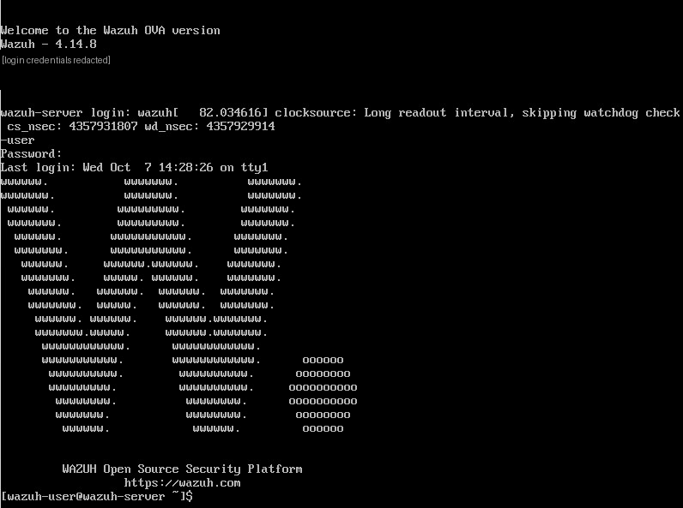
Figure 3: Wazuh 4.14.8 OVA welcome screen (login details hidden)
3.4 THE WAZUH AGENT DOWNLOAD AND THE START OF A LOCAL WEB SERVER (KALI).
On Kali, the Wazuh agent package was downloaded from the official Wazuh repository using the wget command. The file was saved successfully.
A simple web server was then started on port 8000 with the command python3 -m http.server 8000. This hosts the installer file locally so other machines on the private lab network can download it without needing external internet access.
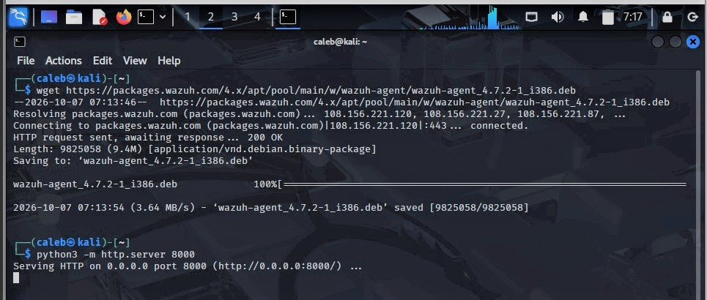
Figure 4: Agent package downloaded and local web server started on Kali
3.5 AGENT FETCHING ONTO METASPLOITABLE 2.
The installer was pulled onto Metasploitable 2 from the Kali web server at 192.168.56.101 on port 8000. The transfer completed successfully and the package was saved locally, ready for installation.
Wazuh website failed with an SSL handshake error. Downloading over plain HTTP from the Kali server inside the private lab avoided the problem.
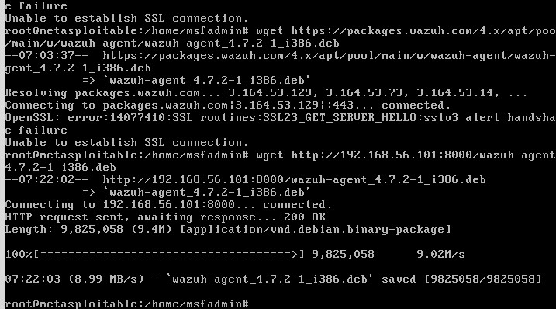
Figure 5: Failed HTTPS attempts, then a successful download from the Kali server
3.6 AGENT REGISTRATION AND KEY EXTRACTION (WAZUH SERVER).
On the Wazuh Manager, the Metasploitable endpoint was registered as agent ID 001. A unique authentication key was then extracted for it. This key establishes trust between the two machines. It unlocks the connection and allows the agent to start sending live security logs to the manager. The agent list was confirmed afterwards, showing the registered agent. The key in the screenshot below has been hidden, as it should be treated like a password.
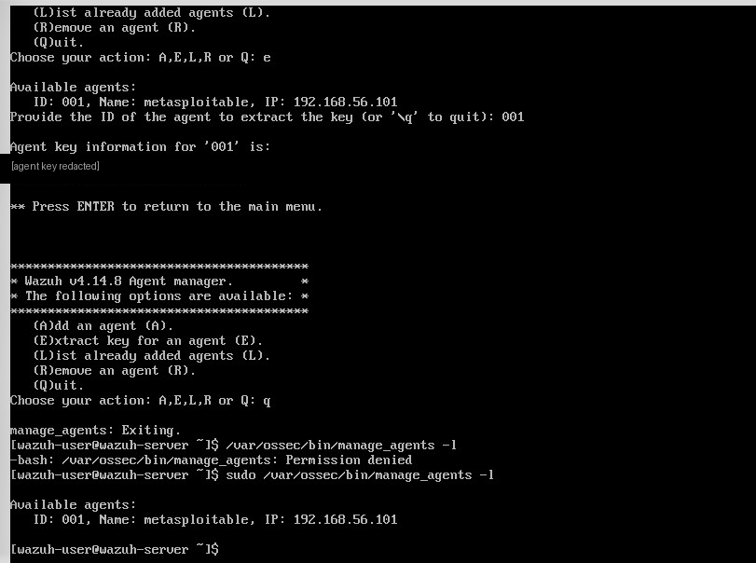
Figure 6: Agent 001 registered and its key extracted (key hidden)
- NETWORK CONFIGURATION.
- NAT – The full meaning is Network Address Translation. It allows your virtual machine to access external networks, including the internet, through your host computer’s network connection.
- NAT Network – It is similar to NAT, but it is designed to let multiple virtual machines share a NAT-based network.
- Bridged Adapter – It allows your virtual machine to connect to your physical network through a network interface on your host computer.
- Internal Network – It allows virtual machines connected to the same named internal network to communicate with each other.
- Host-only Adapter – It allows your host computer and participating virtual machines to communicate through a private virtual network.
- Not Attached – It disconnects the virtual network adapter from its virtual network, it is similar to unplugging a network cable.
- CONCLUSION.
The result of the project we did and stood out;
- A working multi-node lab. A security lab was configured in VirtualBox with Kali Linux, Metasploitable 2 and a Wazuh Manager.
- Simple, offline delivery. Kali was used as a local web server to deliver the Wazuh agent straight to the target system.
- Secure registration. Agent registration and key authentication were established, which enables real-time security log collection and SIEM monitoring.

